Create a Power App which connects to your Sharepoint site list:

This Power App is a no frills IT helpdesk interface linking with the IT tickets you uploaded to your Sharepoint site ‘IT Services’ under the List ‘Service Desk Requests’

1.

Go to the website:

Make.powerapps.com

Sign in as Holly Dickson

Click ‘+ Create’

Home 
Learn 
Apps 
reate 
Data 
HOWS 
Chatoots 
co Al Builder 
Build business 
Create apps that conne( 
Start from 
Blank app 
Create an app from scratc 
then add your data 

Click on 'Blank app'

Blank Canvas App - 'Create'

App name: Scratch

Format: phone

Rename 'Screen1' to 'BrowseScreen1' on the left-pane tree view.

Click 'Insert' on main menu and on the ribbon, select 'gallery' (click on the down arrow on the right)

Canvas 
Settlngs 
Label B'.tton g Ted v 
fx v Wite 
Adatum Corporation 
Holli Dickson 
Data table 
Media v 
ayout 
Wxed Reality v V 
cont'cls .hich represent a 
Gallery 

Click Vertical

Chvtsv 
Scratch 
Icons v C um 
Vertical 

Select sharepoint as the data source in the display properties on the right

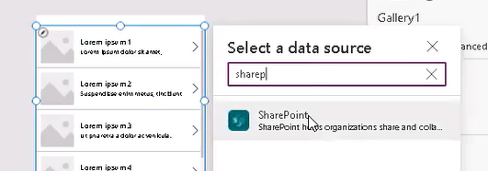

Select IT Services / Service Desk Requests / Connect

Adjust Gallery1 display size leaving some room at the top

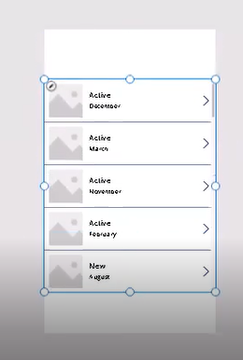

2.

Change Layout

G aller' I 
Fields 
Position 
Service Desk Requests v 
Image. ond 

Select 'title, subtitle, and body'

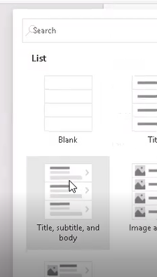

Fields - Edit

Body1 - change to: 'Assign To'

Display value - change to: 'DisplayName'

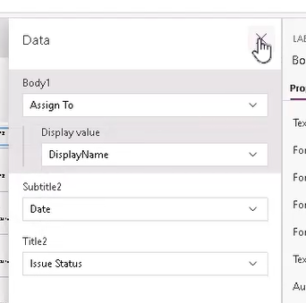

Save button - do not publish yet

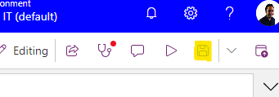

3.

Click Insert on file menu

New Screen - ribbon

Blank

Ноте 
Не.џ В, 

Rename Screen1 to DetailScreen1

Medi• 
EP 

Insert / Forms - ribbon

Display

e Anon Settlngs 
Label v v Data table Forms v 
Edit 
data in • " 
fem 
Tree view 
Set its to this 
Media v 
Charts 

Adjust display leaving some room at the top

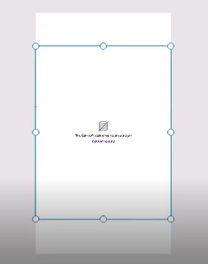

Data source - select Service Desk Requests

Form I 
p tope,ues 
Oat. 
Request' 
Edit felds 

4.

Select 'FormViewer1' (under DetailScreen1)

Function bar below the ribbon:

Change the dropdown 'datasource' to 'item' and in the syntax space type 'Gallery1.Selected1'

As below:

Item = Gallery1.Selected

Gat Ceryl . Selected 
Tree view 
Screens Components 
p Search 
8 rowseSc re en I 
v 00 Gallery I 
Separator2 
NextArrow2 
Body I 
Subtitle? 
Z] Title? 
DetailScreenI 
FormVi ewe rl 
x 

Fields / Edit fields

Drag customer to below Date

Fields 
+ Add field 
X 
O'SPtAV O 
F Viewer I 
Oota 
Fields 
Snip to 
Ideas 
Requests v 
Edit fields 

File / Save / Do not publish

5.

Select Gallery1

Function:

OnSelect = Navigate(DetailScreen1)

New screen v 
On Select 
Tree view 
Label 
Sutton 
x 
Text v 
Date 
Input v 
Navigate(Detai L Screenl ) 
Screens Components 
Search 
8 rowseSc re en I 
v 00 Galleryl 
Separator2 

Click the Play button (triangle arrow) to demo clicking item to navigate from screen1 to detailscreen1

Cus•.orr: v 
Holly Dickson HD 
Mixed Reality v 

Press the Cross on top-right to exit

Select DetailScreen1

Add the Back icon

Canvas 
Action 
Z Label Text v v 
_fx v WhLte 
Tree view 
Screens Components 
App 
Data tade 
F•yms v 
Media v 
Adatum Corporation 
Scratch • Saved (Unpublished) | 
Charts v % Icons v 
Custom v 
Waffle m enu 
> Right 
A Up 
Next 
Arrow down 

Change the Fill colour and tooltip

İdeas 
Stend•rd 
Theme 
Cültom 
ııı•• 

Highlight the back button and change formula to:

OnSelect = Navigate(BrowseScreen1)

Test

Save, do not publish

6.

Create New Screen / Blank

Rename as EditScreen1

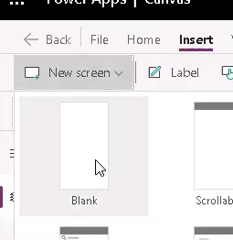

Select Insert / Forms / Edit

Insert 
View Action 
abel 
Vec 
Settings 
Text v 
White 
Input v 
Date 
Forms v 

Adjust screen so it looks like the following size:

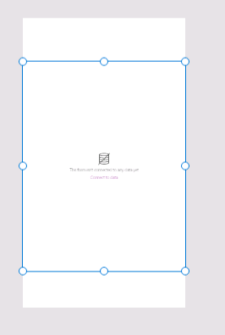

Add datasource in properties - make sure Form1 is selected (under EditScreen1). Ensure ‘Service Desk Requests’ is selected as the Data Source

Formula:

Item = gallery1.selected

Save, do not publish

7.

On BrowseScreen1 - Insert Add Icon

Scratch - Saved (Unpublished) 
Charts v 
+ Add 
Custom 
Mixec 

Ensure Add + icon is highlighted

Function:

OnSelect = NewForm(Form1);Navigate(EditScreen1)

Move to top right

Change Fill colour and tooltip

8.

Add Check (tick) icon to EditScreen1

- Saved (LinpubIishedJ €9 
X Cancel (badge) 
Edit 
Check 
@Check (badge) 

Move position if required

Function:

OnSelect = SubmitForm(Form1)

Select Form1 under EditScreen1

Function:

On Success = Back()

9.

Select Form1 under EditScreen1

Insert Cancel (X) icon

Scratch - Saved (Unpublished) 
Charts v 
+ Add 
Ca cel 
Cancel 
X can 
Custom v 
Mixed R, 

Move to top right

Function:

OnSelect = ResetForm(Form1);Back()

Change Tick icon colour to Green and Cancel icon colour to red

Add tooltips to both icons accordingly

10.

Test

Select BrowseScreen1, press F5

Select Plus to add a new record

Add the following:

23. Populate the form with the following data: 
• Issue Status - Active 
Date - June 
• Issue Title - Test record 
Description - Testing trigger actions 
Location - Home Office 
• Customer - enter Megan and select Megan 
Bowen from the list 
Assign To - leave this field blank 

Assign To - will require a user - add Allan or any other user

Save by clicking the check icon - data will appear in Sharepoint

Save do not publish

11.

Select DetailScreen1

Insert Edit (pencil) icon

Adjust position if required

Function:

OnSelect = EditForm(Form1);Navigate(EditScreen1)

12.

Select DetailScreen1

Insert Trash icon

Adjust position

Function:

On Select =

Remove('Service Desk Requests', Gallery1.Selected);If(IsEmpty(Errors('Service Desk Requests',Gallery1.Selected)), Back())

13.

Select Pencil icon

Choose colour and tooltip

Repeat for trash icon

Test

Save, do not publish

14.

Select BrowseScreen1

Add the Reload icon

Adjust next to Plus icon

OnSelect = Refresh('Service Desk Requests')

Change colour and tooltip

Save

Publish

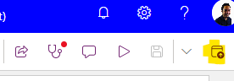

Optional - Access on your mobile

Download the Power Apps app from your phone app store

Sign in as Holly Dickson

You should be able to view the app above on your phone!